**Cloud-Based Disaster Recovery System**

**PHASE 3 : COMMUNICATION AND FUTURE EXPLORATION**

**ABSTRACT:**

Disaster Recovery as a Service (DRaaS) is a lifeline for businesses,

providing a safety net in the unpredictable world of data management. It is a thirdparty service that responds to disasters by protecting data and seamlessly aiding recovery operations. In layman's words, it's similar to having an emergency plan ready to go at any time, but with experts taking care of the details.

At its foundation, DRaaS is based on a subscription model, with

organizations paying for the service as they use it. This means companies don't have to spend considerably in infrastructure up front, making it a more cost-effective option, particularly for smaller enterprises with limited resources. The beauty of DRaaS is its capacity to replicate and host both physical and virtual servers. So, Whether it's a cyberattack, a natural disaster, or any unforeseen incident that causes havoc, DRaaS ensures that operations can seamlessly transition to a secondary system.

But how does the magic happen? It is all about failover and failback. When the primary system fails, failover is the process of seamlessly moving operations to a backup system. It serves as a safety net to keep enterprises from entering a state of indefinite downtime. Once the storm has passed and the primary system is back up and running, failback takes over, seamlessly moving operations back to where they belong. The goal is to minimize disturbance and keep business running as usual, or as close to it as possible, even in the face of adversity.

The emergence of DRaaS is unsurprising given the growing awareness

of data security in the business community. Companies recognize that their data is their lifeline, and any threats to it can have serious effects. They may be confident that their data is safe when they outsource disaster recovery planning to experts. According to Global Market Insights, the DRaaS market was worth USD 11.5 billion in 2022, with a projected 22% growth rate the following year. These figures highlight the growing importance of DRaaS in today's corporate world.

So, what is a disaster recovery plan (DRP), and why is it important? Consider it a crisis response plan. It defines how a business will respond to unexpected occurrences, guaranteeing that they can recover quickly and efficiently. Along with business continuity plans (BCPs), disaster recovery plans (DRPs) form the backbone of a company's resilience strategy, assisting them in weathering disasters.

Effective DRPs require thorough planning and preparation. They

include completing risk assessments, identifying essential assets, assigning roles and duties, and testing the plan on a regular basis to verify it is effective. In the event of a disaster, having a strong DRP in place can be the difference between a quick recovery and extended downtime, possibly saving firms millions in lost income and reputation harm.

However, DRaaS is more than just reacting to calamities; it is also

about taking proactive steps to preserve your data. This is where backup as a service (BaaS) comes in handy. While DRaaS covers both data and infrastructure, BaaS is just about storing your data in secure, offsite places.

It's similar to having a safety deposit box for your most precious digital

assets, ensuring that they remain safe at all times.

Choosing the correct backup location is critical in the DRaaS journey. Whether you choose a data center, the cloud, or a hybrid configuration, each has advantages and disadvantages. Data center backups provide physical security, but they can be expensive and time-consuming to recover. Cloud backups, on the other hand, are scalable and cost-effective, but they might create privacy and security concerns. Hybrid systems combine the benefits of cloud scalability with on-premises infrastructure security.

Finally, the purpose of DRaaS is to provide organizations piece of mind

by ensuring that their data is safe and secure no matter what happens. By outsourcing disaster recovery planning to experts, they can concentrate on what they do best, knowing that their digital lifeline is secure.

The DRaaS industry is rapidly expanding, indicating that organizations

understand its importance in today's data-driven environment.

**SYSTEM REQUIREMENTS:**

**HARDWARE REQUIREMENTS**

1. Processor: Dual-core processor or higher.
2. RAM-4 GB or higher.
3. Storage: At least 100 GB of available disk space (for hosting applications and data).
4. Network: Stable internet connection with sufficient bandwidth for data replication and failover operations.

**SOFTWARE REQUIREMENTS**

1. Operating System: Linux (preferred) or Windows Server.
2. Virtualization Platform: Software like VMware, Hyper-V, or VirtualBox for creating virtual machines (if virtualization is used for hosting servers).
3. Cloud Services: Subscription to a reliable cloud service provider (e.g., AWS, Azure, Google Cloud) for hosting backup infrastructure and facilitating disaster recovery operations.

**TOOLS AND VERSIONS:**

1. Operating System:
   * Linux Distribution: Latest LTS version
2. Virtualization Platformx :
   * VMware vSphere: 7.0 or later
   * Microsoft Hyper-V: Windows Server 2019 or later
   * VirtualBox: 6.1 or later
3. Cloud Service Providers:
   * AWS: Latest version
   * Azure: Latest version
   * GCP: Latest version
4. Networking Equipment:
   * Router/Firewall: Recommended version
   * Switches: Recommended version
5. Monitoring and Management Tools:
   * Nagios: 4.4.6 or later
   * Zabbix: 5.4 or later
   * Prometheus: 2.30.0 or later
6. Backup and Recovery Software:
   * Veeam Backup & Replication: 11 or later
   * Commvault: Latest version
   * Rubrik: Latest version
7. Scripting and Automation:
   * Bash Scripting
   * Python: 3.9 or later - PowerShell: 7.2 or later
8. Security Measures:
   * Antivirus/Anti-malware Software: Latest version
   * Encryption Tools: Latest version
9. Version Control:
   * Git: 2.33 or later
   * GitHub/GitLab/Bitbucket: Latest version
10. Documentation and Collaboration:

* Confluence: Latest version
* Microsoft Teams/Slack: Latest version

11. Development Frameworks and Languages:

* Node.js: 16.x or later
* React.js: Latest version
* Express.js: Latest version
* Java: JDK 11 or later
* Spring Boot: Latest version
* .NET Core: 5.0 or later

**FLOWCHART:**

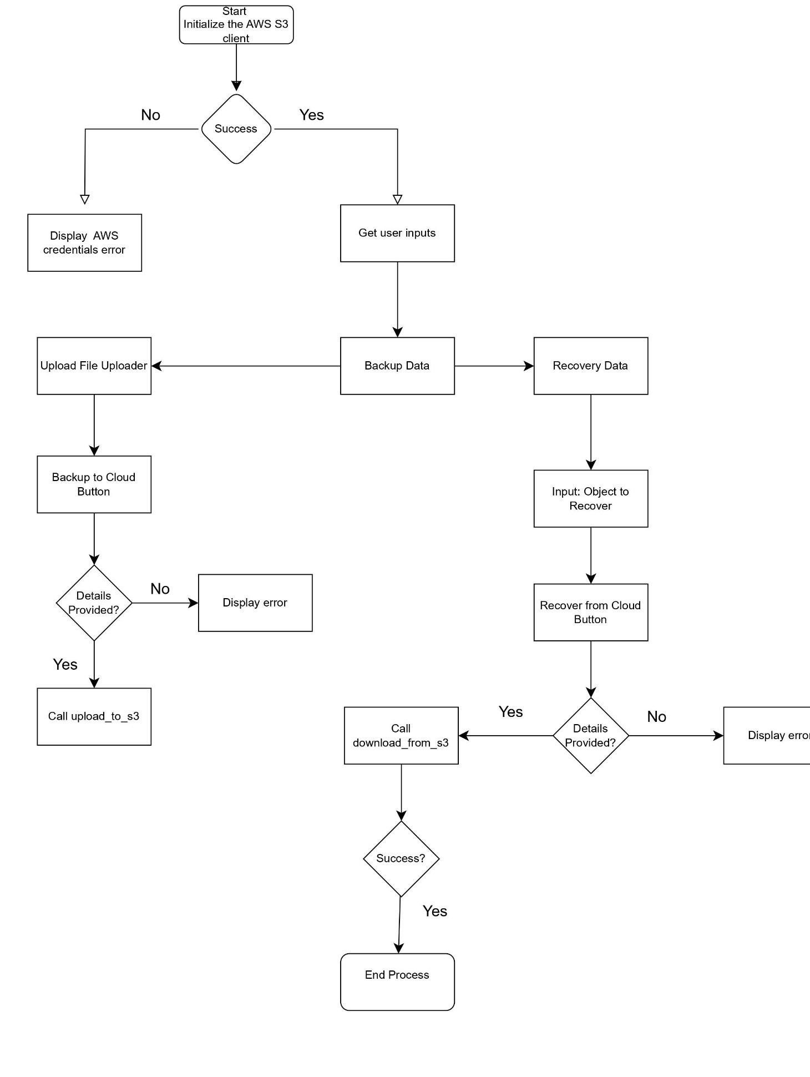

**CODE IMPLEMENTATION(SAMPLE CODE):**

import streamlit as st import boto3

from botocore.exceptions import NoCredentialsError, PartialCredentialsError, ClientError

# Initialize AWS S3 client def init_s3_client(): try:

return boto3.client('s3') except (NoCredentialsError, PartialCredentialsError): st.error("AWS credentials not found. Please configure your AWS credentials.") return None

# Function to upload data to S3 def upload_to_s3(file, bucket_name, object_name, s3_client): try:

s3_client.upload_fileobj(file, bucket_name, object_name) return True except NoCredentialsError:

st.error("Credentials not available.")

return False except ClientError as e:

st.error(f"Failed to upload file: {e}") return False

# Function to download data from S3 def download_from_s3(bucket_name, object_name, download_path, s3_client): try:

s3_client.download_file(bucket_name, object_name, download_path) return True except NoCredentialsError:

st.error("Credentials not available.")

return False except ClientError as e: st.error(f"Failed to download file: {e}") return False

# Streamlit app

st.title("Cloud Disaster Recovery System")

# Initialize S3 client

s3_client = init_s3_client()

if s3_client: # Configuration

bucket_name = st.text_input("S3 Bucket Name:") backup_path = st.text_input("Backup Path (S3 object name):") restore_path = st.text_input("Restore Path (local path):")

# Backup data st.header("Backup Data")

file_to_backup = st.file_uploader("Choose a file to backup")

if st.button("Backup to Cloud"): if file_to_backup is not None and bucket_name and backup_path:

success = upload_to_s3(file_to_backup, bucket_name, backup_path, s3_client) if success:

st.success("File backed up successfully!") else:

st.error("Please provide all the necessary details.")

# Recover data st.header("Recover Data")

object_to_recover = st.text_input("Object to Recover from Cloud (S3 object name):")

if st.button("Recover from Cloud"):

if object_to_recover and bucket_name and restore_path:

success = download_from_s3(bucket_name, object_to_recover, restore_path, s3_client) if success:

st.success("File recovered successfully!") else: st.error("Please provide all the necessary details.")

**PROJECT HURDLES:**

During the execution of our project, we faced several challenges. Integrating AWS S3 with our Streamlit application proved especially tough due to credential management and guaranteeing secure access. Debugging issues in file uploads and downloads necessitated substantial debugging. Furthermore, coordinating work across team members with different schedules and technical competence hindered our progress. Despite these challenges, we were able to strengthen our problemsolving skills and awareness of cloud services.

**OUTPUT:**

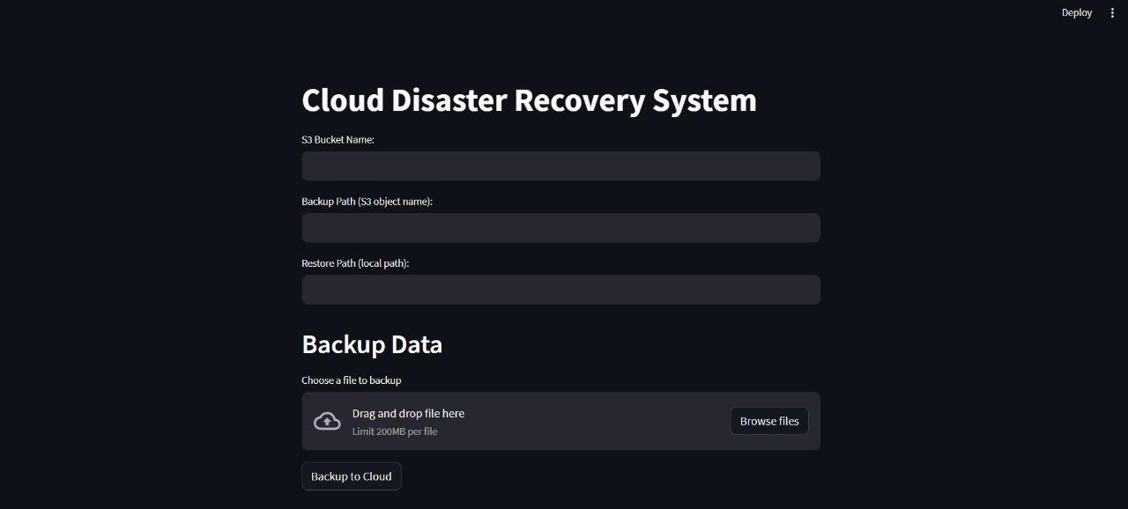

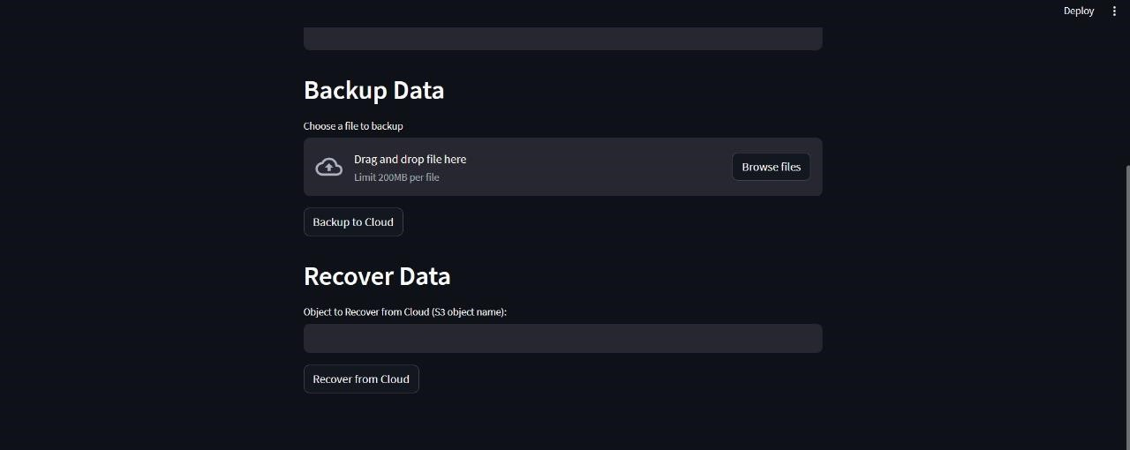

**CONCLUSION AND FUTURE SCOPE:**

To summarize, Disaster Recovery as a Service (DRaaS) provides a critical safety net for businesses, ensuring that data is safeguarded and recovery processes run smoothly in the case of disaster. DRaaS runs on a subscription basis, making it an affordable alternative, particularly for smaller businesses. Its capacity to replicate and host both physical and virtual servers means that enterprises may continue to operate even amid bad occurrences. The essential principles of failover and failback allow operations to seamlessly move between primary and secondary systems, reducing downtime and interruption.

DRaaS deployment involves a number of components and considerations. A strong disaster recovery plan (DRP) is required, defining how a company will respond to unanticipated catastrophes. Effective DRPs necessitate meticulous preparation, including risk assessments, asset identification, role allocations, and regular testing. Backup as a Service (BaaS) complements DRaaS by focusing on safely storing data offsite.

Our project entailed creating a cloud-based disaster recovery system with AWS S3 and Streamlit. We specified the hardware and software requirements, including the required tools and versions. The study emphasized the significance of having the necessary infrastructure and tools in place for efficient data replication and recovery.

One of the most difficult issues we encountered was integrating AWS S3 with our Streamlit application. Managing credentials securely and ensuring smooth file uploads and downloads necessitated extensive testing and problem-solving. Furthermore, coordinating work among team members with different schedules and technical knowledge presented difficulties, but ultimately increased our teamwork and technical skills.

Looking ahead, the scope of this endeavor is broad. As the DRaaS market expands, driven by growing awareness of data security, there are various opportunities for continued development and enhancement:

1. Enhanced Security Measures: Using advanced security protocols like multi-factor authentication and encryption at rest and in transit can help secure data during replication and recovery.
2. AI and machine learning techniques can help improve disaster recovery prediction analytics. These technologies can assist identify possible risks and optimize recovery tactics, decreasing downtime and increasing efficiency.
3. Automation and Orchestration: Creating automated workflows for failover and failback operations can reduce the need for human intervention and the risk of errors. Orchestration solutions help speed up the recovery process by guaranteeing a smooth transition between primary and secondary systems.
4. Scalability and Flexibility: Extending the system to handle multi-cloud environments can improve flexibility and redundancy. This would enable enterprises to use the qualities of many cloud providers, resulting in increased availability and reliability.
5. User Experience Improvements: By improving the disaster recovery application's user interface and experience, it can become more intuitive and accessible. Real-time monitoring, rich analytics, and customisable dashboards can help customers gain more control and visibility over their recovery procedures.
6. Compliance and Regulatory Support: It is critical to ensure that the DRaaS solution meets all relevant regulatory requirements and industry standards. Implementing tools that enable compliance reporting and audit trails can assist firms in meeting their legal and regulatory duties.

To summarize, creating a cloud-based disaster recovery system is an important step toward ensuring business continuity in the case of disasters. Businesses may protect their digital assets and keep operations running smoothly by embracing new technology and constantly improving the system's capabilities. The future of DRaaS seems exciting, with multiple prospects for innovation and development that will ultimately provide organizations with more peace of mind and resilience.